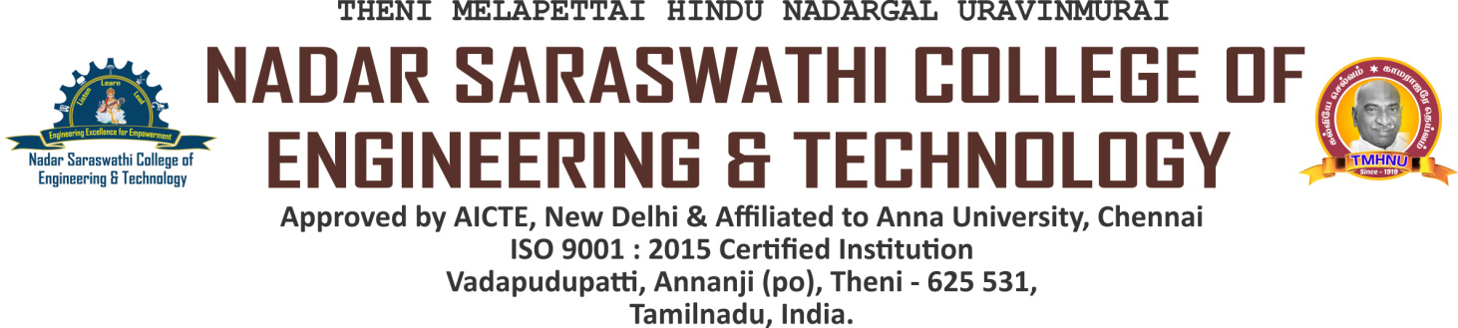

NAAC DVV CLARIFICATIONS

**CRITERION 5 - STUDENT SUPPORT AND PROGRESSION**

**Documents relating to placement cell such as Tie-Ups**

**FUNCTIONAL MOU’S**

|  |  |  |
| --- | --- | --- |
| **S.NO.** | **NAME OF THE TIE-UPS** | **DOCUMENTS** |
| **ACADEMIC YEAR 2022-2023** | | |
|  | DESOMETRIC ENGINEERING SERVICES | **[VIEW](https://nscet.org/ssr/dvv-clarification/c5/5.2.1/5.2.1 placement tie-ups/1 MOU_DSM_NSCET.pdf)** |
|  | INFOSYS | **[VIEW](https://nscet.org/ssr/dvv-clarification/c5/5.2.1/5.2.1 placement tie-ups/2 Infosys.pdf)** |
|  | NSK AUTOMOTIVE | **[VIEW](https://nscet.org/ssr/dvv-clarification/c5/5.2.1/5.2.1 placement tie-ups/3 NSK Automotive.pdf)** |
|  | YAZHINI RUBBERS | **[VIEW](https://nscet.org/ssr/dvv-clarification/c5/5.2.1/5.2.1 placement tie-ups/4 Yazhini Rubbers.pdf)** |
|  | ARAN TECHNOLOGIES | **[VIEW](https://nscet.org/ssr/dvv-clarification/c5/5.2.1/5.2.1 placement tie-ups/5 ARAN Technologies.pdf)** |
|  | JUST INTEGRATE IT | **[VIEW](https://nscet.org/ssr/dvv-clarification/c5/5.2.1/5.2.1 placement tie-ups/6  Just Integrate IT.pdf)** |
|  | SPICA TECH SOFTWARE SERVICES | **[VIEW](https://nscet.org/ssr/dvv-clarification/c5/5.2.1/5.2.1 placement tie-ups/7 SPICA Tech.pdf)** |
|  | HEARTFULNESS EDUCATION TRUST | **[VIEW](https://nscet.org/ssr/dvv-clarification/c5/5.2.1/5.2.1 placement tie-ups/8 Heartfulness Education Trust.pdf)** |
|  | VIKEBIKE INDIA PRIVATE LIMITED | **[VIEW](https://nscet.org/ssr/dvv-clarification/c5/5.2.1/5.2.1 placement tie-ups/9 Vike Bike India Pvt Ltd Theni.pdf)** |
|  | INIAN MOTORS | **[VIEW](https://nscet.org/ssr/dvv-clarification/c5/5.2.1/5.2.1 placement tie-ups/10 INIAN Motors.pdf)** |
|  | SNK INTERLOCK BRICKS | **[VIEW](https://nscet.org/ssr/dvv-clarification/c5/5.2.1/5.2.1 placement tie-ups/11 SNK Interlock Bricks.pdf)** |
| **ACADEMIC YEAR 2021-2022** | | |
|  | SRI VINAYAGA ENGINEERING WORKS | **[VIEW](https://nscet.org/ssr/dvv-clarification/c5/5.2.1/5.2.1 placement tie-ups/12 Sri Vinayaka Engineering Works.pdf)** |
|  | THENI AISWARYAM POLY PLASTICS INDUSTRIES | **[VIEW](https://nscet.org/ssr/dvv-clarification/c5/5.2.1/5.2.1 placement tie-ups/13 Theni Aiswaryam Polyplastics.pdf)** |
|  | ACLUDE FOUNDATION | **[VIEW](https://nscet.org/ssr/dvv-clarification/c5/5.2.1/5.2.1 placement tie-ups/14 Aclude Foundations.pdf)** |
|  | S.D.EXPORTS | **[VIEW](https://nscet.org/ssr/dvv-clarification/c5/5.2.1/5.2.1 placement tie-ups/15 S.D Exports.pdf)** |
|  | R.M.R AUTOMATIONS | **[VIEW](https://nscet.org/ssr/dvv-clarification/c5/5.2.1/5.2.1 placement tie-ups/16 R.M.R Automations.pdf)** |
|  | CADD CENTER TRAINING SERVICES | **[VIEW](https://nscet.org/ssr/dvv-clarification/c5/5.2.1/5.2.1 placement tie-ups/17 CADD.pdf)** |
|  | SYSTIMANX IT SOLUTIONS PRIVATE LTD | **[VIEW](https://nscet.org/ssr/dvv-clarification/c5/5.2.1/5.2.1 placement tie-ups/18 Systimanx.pdf)** |
|  | PRO DESIGNA CONSULTANTS | **[VIEW](https://nscet.org/ssr/dvv-clarification/c5/5.2.1/5.2.1 placement tie-ups/19 Pro Designa.pdf)** |
|  | LIVE WIRE ( A DIVISION OF CADD CENTRE TRAINING SERVICES | **[VIEW](https://nscet.org/ssr/dvv-clarification/c5/5.2.1/5.2.1 placement tie-ups/20 Livewire.pdf)** |
| **ACADEMIC YEAR 2020-2021** | | |
|  | SYNERGY GROUP OF COMPANIES | **[VIEW](https://nscet.org/ssr/dvv-clarification/c5/5.2.1/5.2.1 placement tie-ups/21 Synergy Group.pdf)** |
|  | KMC ASSOCIATES | **[VIEW](https://nscet.org/ssr/dvv-clarification/c5/5.2.1/5.2.1 placement tie-ups/22 KMC.pdf)** |
|  | BHARATH NIKETAN ENGINEERING COLLEGE | **[VIEW](https://nscet.org/ssr/dvv-clarification/c5/5.2.1/5.2.1 placement tie-ups/23 Bharath Niketan.pdf)** |
| **ACADEMIC YEAR 2019-2020** | | |
|  | SETHU INSTITUTE OF TECHNOLOGY | **[VIEW](https://nscet.org/ssr/dvv-clarification/c5/5.2.1/5.2.1 placement tie-ups/24 SETHU MOU.pdf)** |
|  | HOLYCROSS ENGINEERING COLLEGE  THOOTHUKUDI | **[VIEW](https://nscet.org/ssr/dvv-clarification/c5/5.2.1/5.2.1 placement tie-ups/25 Hollycross.pdf)** |
| **ACADEMIC YEAR 2018-2019** | | |
|  | MANGAYARKARASI COLLEGE OF ENGINEERING,  PARAVAI, MADURAI | **[VIEW](https://nscet.org/ssr/dvv-clarification/c5/5.2.1/5.2.1 placement tie-ups/26 mangai.pdf)** |
|  | AS-SALAM COLLEGE OF ENGINEERING AND  TECHNOLOGY, THIRUMANGALAKUDI, THANJAVUR | **[VIEW](https://nscet.org/ssr/dvv-clarification/c5/5.2.1/5.2.1 placement tie-ups/27 As Salam.pdf)** |